**BMS18 – Heterogeneity – subgroup analysis and meta-regression**

**Self study assignment**

**Estimated time: 2 hours**

**Topics:**

1. Reading: Borenstein on subgroup analysis and meta-regression
2. Simple meta-analysis: topical steroids example
   * Discussion Hartung-Knapp (HKSJ) vs. Normal distribution for confidence intervals
   * Prediction intervals vs. Confidence intervals
   * Sensitivity analysis
3. Meta-regression for RR outcome.
4. Preparation for next week.

**For this assignment you need R and RStudio.**  
You can download this for free at your private laptop, or use the Radboudumc computer rooms.

An installer for R (for various platforms) can be downloaded from

<http://cran.us.r-project.org/>

An installer for RStudio (desktop) can be downloaded from

<https://www.rstudio.com/products/rstudio/download3/#download>

# Read the chapter from Borenstein on subgroup analysis and meta-regression

Introduction to meta-analysis   
<https://onlinelibrary.wiley.com/doi/book/10.1002/9780470743386>

# Topical steroids for treatment of chronic rhinosinusitis with nasal polyps

A 2012 Cochrane review on the use of topical steroids for treatment of chronic rhinosinusitis with nasal polyps, based on seven randomised studies, resulted in a larger decrease in overall symptom scores in favour of steroids compared with placebo.

This is reflected by a standardised mean difference (SMD) of −0.51. The I2 is 73.9% (95% CI 44.2% to 87.8%), which can be considered substantial heterogeneity according to the Cochrane Handbook, and the estimated τ2 is 0.148.

Notwithstanding these numbers, it is difficult to evaluate what the clinical consequences of this heterogeneity may be for future settings.

[ Kalish L, Snidvongs K, Sivasubramaniam R, et al. Topical steroids for nasal polyps. Cochrane Database Syst Rev 2012;12: CD006549.]

We will investigate this example step by step, starting with a short refresher of the theory of last week.

1. We will conduct a fixed and a random-effects meta-analysis for this example.   
   Consider a small study, taken from a meta-analysis with quite some between-study heterogeneity. Is this study relatively more important (for the pooled result) in a fixed-effect or in a random-effects meta-analysis? Explain your answer.
2. Conduct a fixed and a random-effects meta-analysis, using the EB estimator for the tau2. The effect size measure (sm=) is the SMD. Data to be used are in *topical_steroids.xlsx*.   
     
   Compare the width of the 95% CI for the fixed effect and the random-effects meta-analyses. Which one is wider? Why?  
     
   Also check the weights. What happened to the weights if you compare the fixed and the random effects weights?
3. By default, most meta-analysis programs assume that the number of studies in the meta-analysis is large. In that situation, the 95% CI can be calculated using the normal (z-) distribution, i.e. as   
    *pooled estimate ± 1.96 x SE*Also in meta this is the default approach, so the 95% CI that is calculated by meta (and also by RevMan) is based on this z-distribution. This is based on the assumption that we have a precise estimate of the standard error for the calculation of the confidence interval.  
     
   Use the results of the random-effects meta-analysis to report the pooled estimate and the 95% CI for the SMD between the steroids and placebo.
4. Often the number of studies is small, like in our example, where we have 7 studies. In that situation the SE that is needed to calculate the confidence interval cannot be estimated very precise. The use of the factor 1.96 to calculate the 95% CI will result in confidence intervals that are too optimistic, i.e. too narrow.   
   A better approach is to use the Hartung-Knapp ( or: HKSJ) method to calculate the confidence intervals. This method is based on the t-distribution instead of the normal distribution, with as degrees of freedom the number of studies – 1. If the number of studies is large (>30) the t-value will be around 2, and very similar to the z-value 1.96, but for a lower number of studies, the t-value will be larger, which results in a wider 95% CI.   
   (Note that the HKSJ method is a bit more complex than we state here).

Report the pooled estimate and the 95% CI for the SMD , based on the Hartung-Knapp approach (hakn=TRUE). Compare the width of this confidence interval with the previous result.   
Do you know which t-value has been used? (you can use a table to find the t-value, or calculate it from the confidence intervals)

1. Make a forest plot for the meta-analysis that you conducted in the previous step.
2. If you look at the forest plot, you will see that the confidence interval is much smaller than the range of treatment effect estimates of the studies. Which treatment effect can we expect if we would apply the topical steroid in our own hospital?



1. Most software for meta-analysis will not generate by default a prediction interval, although it is one of the most essential outcomes in a ‘random effects’ model, i.e. when it must be assumed that ‘true’ effect sizes vary, and much easier to understand than the other measures for heterogeneity like tau2.

**What is the difference between the confidence and prediction intervals of the combined effect size?**

1. **Sometimes, the HKSJ confidence interval of the combined effect size is larger than the confidence intervals of the individual effect sizes, specifically with a low number of studies?** Do you have any idea how this can happen?
2. The weights represent the influence of the individual studies on the combined effect. However, some studies are further away from the pooled effect estimate than others. We can also conduct a sensitivity analysis, by investigating what happens to the pooled effect if each time, one study is removed from the meta-analysis.   
     
   Do this with the metainf command in the package meta, based on the meta-analysis result that you created before, e.g.:  
     
   metainf(result.meta, pooled = "random")

You will see the results of the meta-analysis of 6 studies, i.e. omitting one study, and the result for the pooled estimate as before, based on the 7 studies.   
  
Which (omitted) study has a large effect on the pooled estimate? What is the effect of omitting this study / these studies (one by one)? If you would be conducting this meta-analysis, this could be a reason to have a more in depth look again at the article of this author.

# Blood pressure lowering treatment for prevention of cardiovascular disease

**Background   
The benefits of blood pressure lowering treatment for prevention of cardiovascular disease are well established. However, the extent to which these effects differ by drug class or other factors is less clear. Ettehad et al. (Lancet, 2016) performed a systematic review and meta-analysis to clarify these differences.**

**Medline was searched for large-scale blood pressure lowering trials. Randomised controlled trials of blood pressure lowering treatment were eligible for inclusion if they included a minimum of 1000 patient-years of follow-up in each study arm.**

**In total, the authors included 123 studies with 613,815 participants.**

1. **To evaluate the relation between reduction in major cardiovascular disease events in relation to the achieved blood pressure reduction, the authors performed meta-regression.   
   This resulted in an estimated risk ratio (RR) of 0.80 per 10 mmHg of reduction.**

**How large is the reduction in the risk for major cardiovascular disease events per 10 mmHg blood pressure reduction?**

1. **Assume a cardiovascular disease event rate of 10% in the control group.   
   Explain which event rate you expect in the experimental group if the difference in Systolic Blood Pressure (SBP) between the control and experimental group is 10 mmHg?**
2. **And what event rate do you expect in the experimental group if the difference is 15 mmHg?**

**Figure 2.1 (below) shows the fixed-effect meta-regression results for all-cause mortality in relation to systolic blood pressure reduction. Studies are indicated with small and large circles (bubbles).**

1. **The bubble sizes are related to the weights of the studies in the meta-regression.**
2. **Try to give a formula for the regression line.**

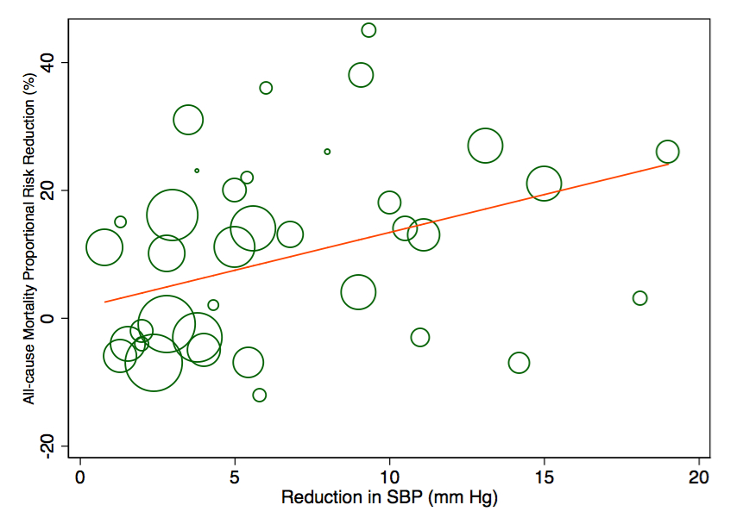

*Figure 2.1****.***  *Meta-regression plot of the percentage risk reduction in all-cause mortality (y‑axis) regressed against the difference in achieved systolic blood pressure (SBP) between treatment arms (x-axis).*

# Preparation for next week:

Next week we will discuss publication bias.

Prepare by viewing the following TED talk from 2011, by Ben Goldacre (14:19 minutes), known for his criticism of bad science and bad pharma.

[https://www.ted.com/talks/ben_goldacre_battling_bad_science?language=en#t-274330](https://www.ted.com/talks/ben_goldacre_battling_bad_science?language=en)

